78

**One-Dimensional Arrays**

Department of Computer Science and Engineering, Rajalakshmi Engineering College

79

# Check pair with difference k

**Problem Statement:**

Given an array A of sorted integers and another non negative integer k, find if there exists 2 indices i and j such that A[i] - A[j] = k, i != j.

Input Format

1. First line is number of test cases T. Following T lines contain:
2. N, followed by N integers of the array
3. The non-negative integer k

Output format

Print 1 if such a pair exists and 0 if it doesn’t.

Sample Input: 1

3 1 3 5

4

Sample Output: 1

Department of Computer Science and Engineering, Rajalakshmi Engineering College

80

**Program:**

**#include <stdio.h>**

**int find_pair(int A[], int N, int k) { int i = 0, j = N - 1;**

**while (i < j) {**

**int diff = A[j] - A[i];**

**if (diff == k) {**

**return 1; // Pair found**

**}**

**else if (diff > k) {**

**j--; // Decrease the difference**

**} else {**

**i++; // Increase the difference**

**}**

**}**

**return 0; // No pair found**

**}**

**int main() { int T;**

**scanf("%d", &T); // Read the number of test cases**

**while (T--) { int N, k;**

**scanf("%d", &N); // Read the size of the array**

**int A[N];**

**for (int i = 0; i < N; i++) {**

**scanf("%d", &A[i]); // Read the array elements**

**}**

**scanf("%d", &k); // Read the value of k**

**// Call the function to check if a valid pair exists int result = find_pair(A, N, k);**

**// Output the result printf("%d\n", result);**

**}**

**return 0;**

**}**

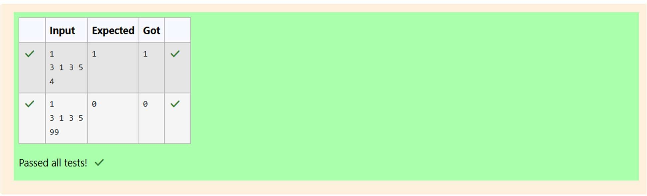

Department of Computer Science and Engineering, Rajalakshmi Engineering College

81

# Chocolates

**Problem Statement:**

Sam loves chocolates and starts buying them on the 1st day of the year. Each day of the year, x, is numbered from 1 to Y. On days when x is odd, Sam will buy x chocolates; on days when x is even, Sam will not purchase any chocolates.

Complete the code in the editor so that for each day Ni (where 1 ≤ x ≤ N ≤ Y) in array arr, the number of chocolates Sam purchased (during days 1 through N) is printed on a new line. This is a function-only challenge, so input is handled for you by the locked stub code in the editor.

Input Format

The program takes an array of integers as a parameter.

The locked code in the editor handles reading the following input from stdin, assembling it into an array of integers (arr), and calling calculate(arr).

The first line of input contains an integer, T (the number of test cases). Each line i of

the T subsequent lines describes the ith test case as an integer, Ni (the number of days).

Constraints

1 ≤ T ≤ 2 × 105

1 ≤ N ≤ 2 × 106

1 ≤ x ≤ N ≤ Y

Output Format

For each test case, Ti in arr, your calculate method should print the total number of chocolates Sam purchased by day Ni on a new line.

Sample Input 0

3

1

2

3

Sample Output 0

1

1

4

Department of Computer Science and Engineering, Rajalakshmi Engineering College

82

**Program:**

**#include <stdio.h>**

**// Function to calculate the chocolates purchased by day N void calculate(int arr[], int T) {**

**for (int i = 0; i < T; i++) { int N = arr[i];**

**// Number of odd days from 1 to N is (N + 1) / 2 int odd_days_count = (N + 1) / 2;**

**// The total chocolates purchased is the square of the odd days count int total_chocolates = odd_days_count * odd_days_count;**

**// Print the result for the current test case printf("%d\n", total_chocolates);**

**}**

**}**

**int main() { int T;**

**// Read the number of test cases scanf("%d", &T);**

**// Create an array to store all the test cases int arr[T];**

**// Read all test cases for (int i = 0; i < T; i++) {**

**scanf("%d", &arr[i]);**

**}**

**// Call the calculate function to process the test cases calculate(arr, T);**

**return 0;**

**}**

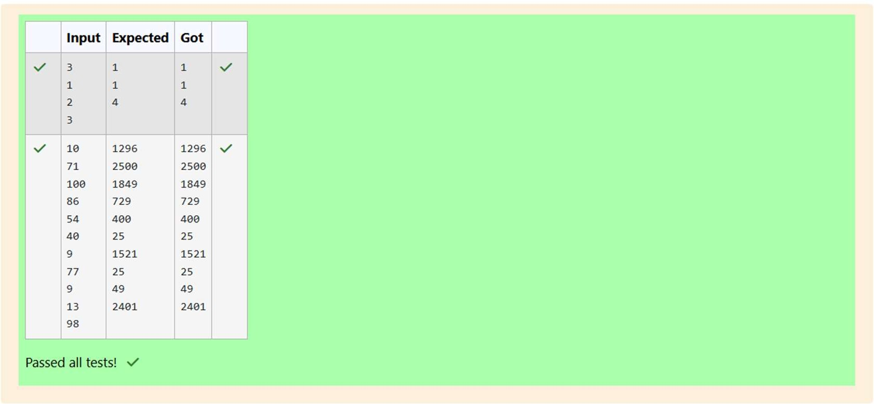

Department of Computer Science and Engineering, Rajalakshmi Engineering College

83

# Football Scores

**Problem Statement:**

The number of goals achieved by two football teams in matches in a league is given in the form of two lists. Consider:

* Football team A, has played three matches, and has scored { 1 , 2 , 3 } goals in each match respectively.
* Football team B, has played two matches, and has scored { 2, 4 } goals in each match respectively.
* Your task is to compute, for each match of team B, the total number of matches of team A,
* where team A has scored less than or equal to the number of goals scored by team B in that match.

In the above case:

* For 2 goals scored by team B in its first match, team A has 2 matches with scores 1 and 2.
* For 4 goals scored by team B in its second match, team A has 3 matches with scores 1, 2 and 3. Hence, the answer: {2, 3}.

Complete the code in the editor below. The program must return an array of m positive integers, one for each maxes[i] representing the total number of elements nums[j] satisfying nums[j] ≤ maxes[i] where 0 ≤ j < n and 0 ≤ i < m, in the given order.

It has the following:

nums[nums[0],...nums[n-1]]: first array of positive integers maxes[maxes[0],...maxes[n-1]]: second array of positive integers

Constraints:

2 ≤ n, m ≤ 105, 1 ≤ nums[j] ≤ 109, where 0 ≤ j < n, 1 ≤ maxes[i] ≤ 109, where 0 ≤ i < m.

Input Format For Custom Testing

Input from stdin will be processed as follows and passed to the function. The first line contains an integer n, the number of elements in nums.

The next n lines each contain an integer describing nums[j] where 0 ≤ j < n. The next line contains an integer m, the number of elements in maxes.

The next m lines each contain an integer describing maxes[i] where 0 ≤ i < m.

Sample Input 4

1

4

2

4

2

3

5

Sample Output 2

4

Department of Computer Science and Engineering, Rajalakshmi Engineering College

|  |  |  |  |
| --- | --- | --- | --- |
| GE23131 - Programming Using C | | | |
|  | **Program:**  #include<stdio.h>  int main()  {  int s1,s2,ans;  scanf("%d",&s1);  int ta[s1];  for(int i=0;i<s1;i++)  scanf("%d",&ta[i]);  scanf("%d",&s2);  int tb[s2];  for(int i=0;i<s2;i++)  scanf("%d",&tb[i]);  for(int j=0;j<s2;j++)  {  ans=0;  for(int i=0;i<s1;i++){  if(tb[j]>=ta[i])  ans++;  }printf("%d\n",ans);  }  } |  | |
|  | 84 |  |
|  | |

GE23131 - Programming Using C

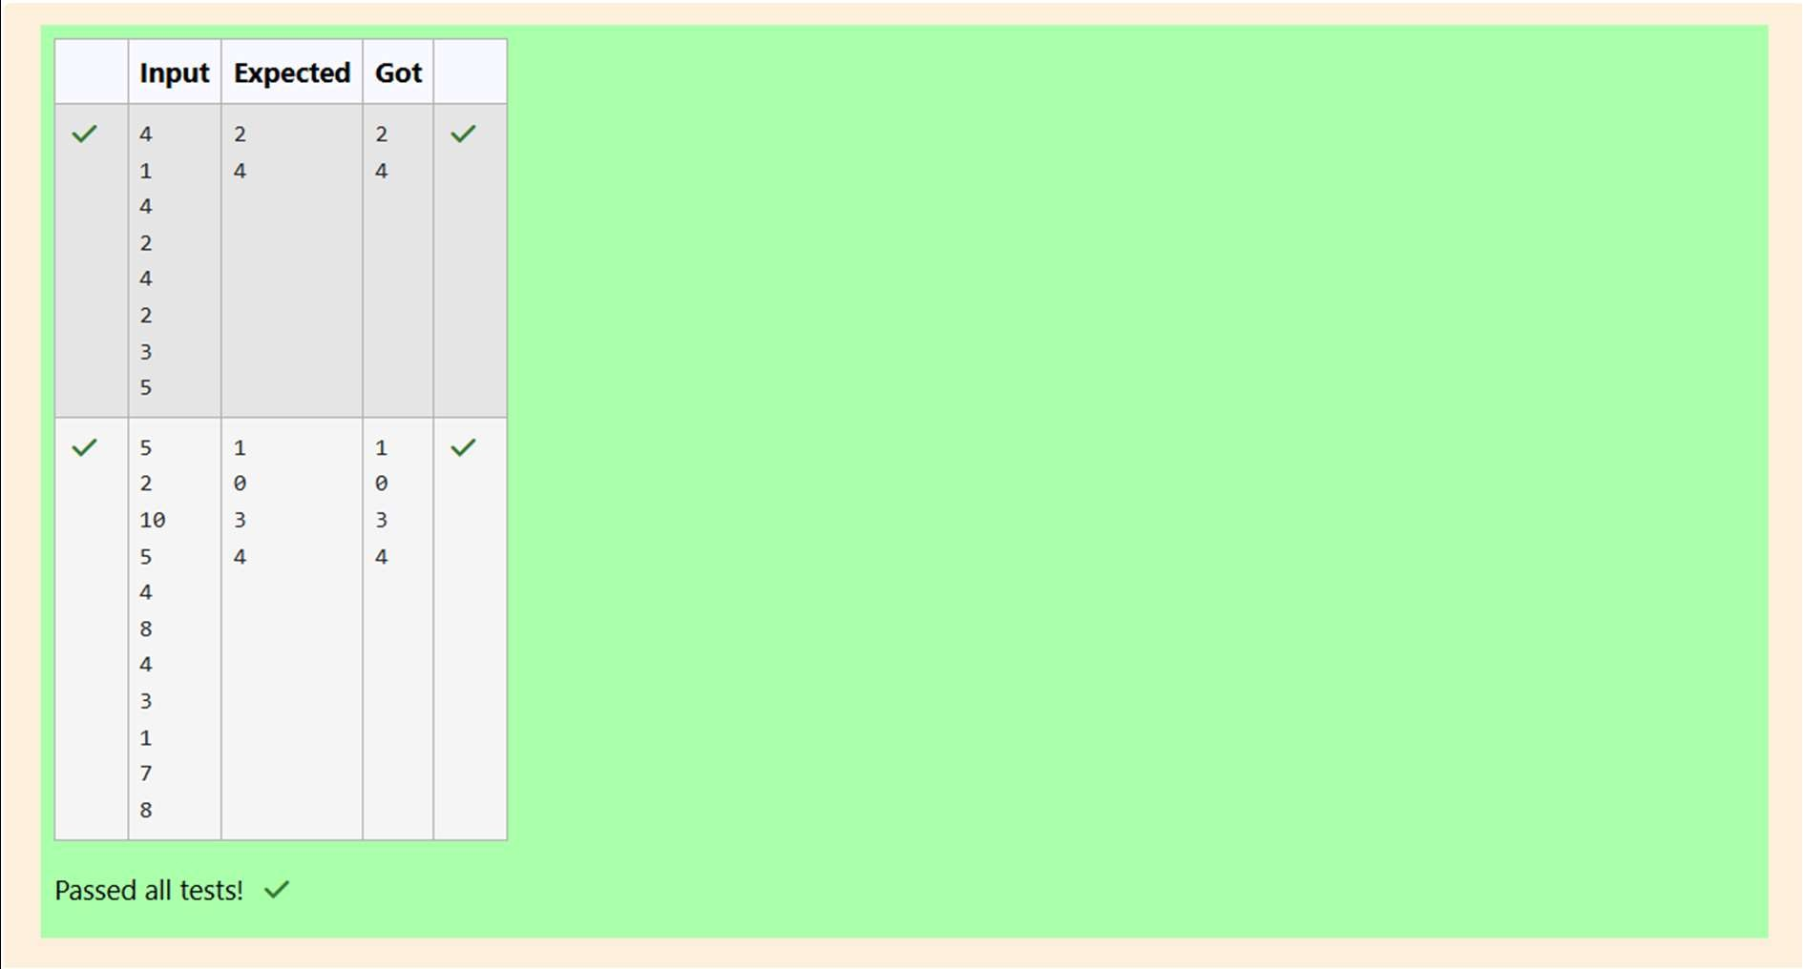

Department of Computer Science and Engineering, Rajalakshmi Engineering College